WATER ANALYSIS DESIGN

Designing a water analysis involves several steps and considerations to ensure accurate and reliable results. Here's a detailed guide to help you plan and execute a water analysis:

# ### Step 1: Define Objectives and Scope

* Clearly state the purpose of the analysis (e.g., assessing water quality for drinking, environmental monitoring, industrial process).
* Define the parameters you want to measure (e.g., pH, turbidity, dissolved oxygen, heavy metals, bacteria).
* Determine the frequency of analysis (one-time assessment, periodic monitoring, continuous monitoring).

# ### Step 2: Select Sampling Sites

* Identify representative locations where you'll collect water samples. These should be chosen based on the objectives and the potential sources of contamination.
* Consider factors like proximity to pollution sources, natural variation, and accessibility.

# ### Step 3: Plan Sample Collection

* Determine the appropriate sampling methods for each parameter. For example, pH might require a different technique than collecting samples for heavy metal analysis.
* Use clean, sterilized containers for sample collection to prevent contamination.
* Follow established protocols for sample handling and preservation. For example, some parameters may require specific storage temperatures or the addition of preservatives.

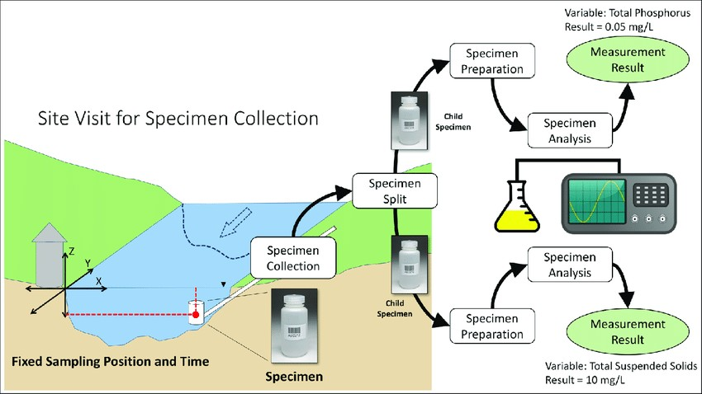

# ### Step 4: Equipment and Reagents

* Prepare a list of necessary equipment and reagents for each parameter to be analyzed.

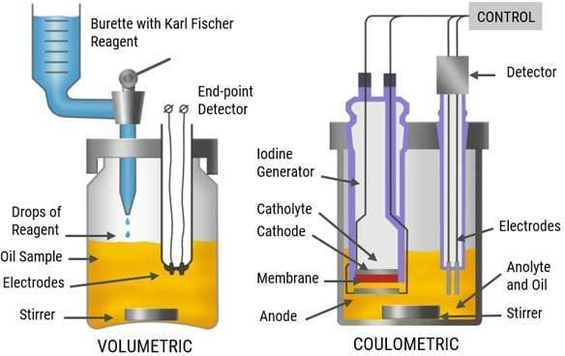

This may include:

- pH meter or indicator strips

* + Turbidity meter
* Dissolved oxygen meter
* Chemical reagents (e.g., titrants, indicators)
* Analytical instruments (e.g., spectrophotometer, ICP-MS for heavy metals)
  + Safety equipment (e.g., gloves, lab coats, goggles)

Water analysis involves assessing the chemical, physical, and biological characteristics of water. It is crucial for various purposes, including ensuring safe drinking water, monitoring environmental conditions, and supporting industrial processes. Here are some key aspects of water analysis

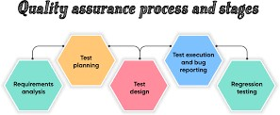

# ### Step 5: Quality Control Measures

* Implement quality control procedures to ensure the accuracy and precision of your results. This may include:
  + Calibrating instruments regularly using standard solutions.
  + Running blanks (pure water samples) and duplicates to check for contamination and repeatability.
  + Participating in inter-laboratory proficiency testing programs, if available.

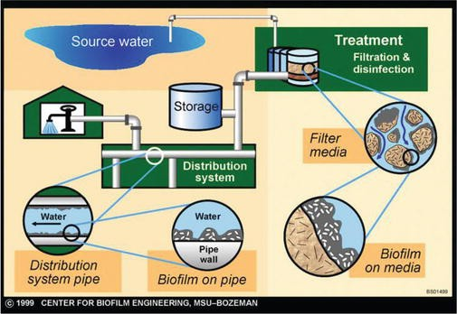

# ### Step 6: Analytical Methods

* Develop or select appropriate analytical methods for each parameter. This could involve chemical tests, instrumental analysis, or microbiological techniques.

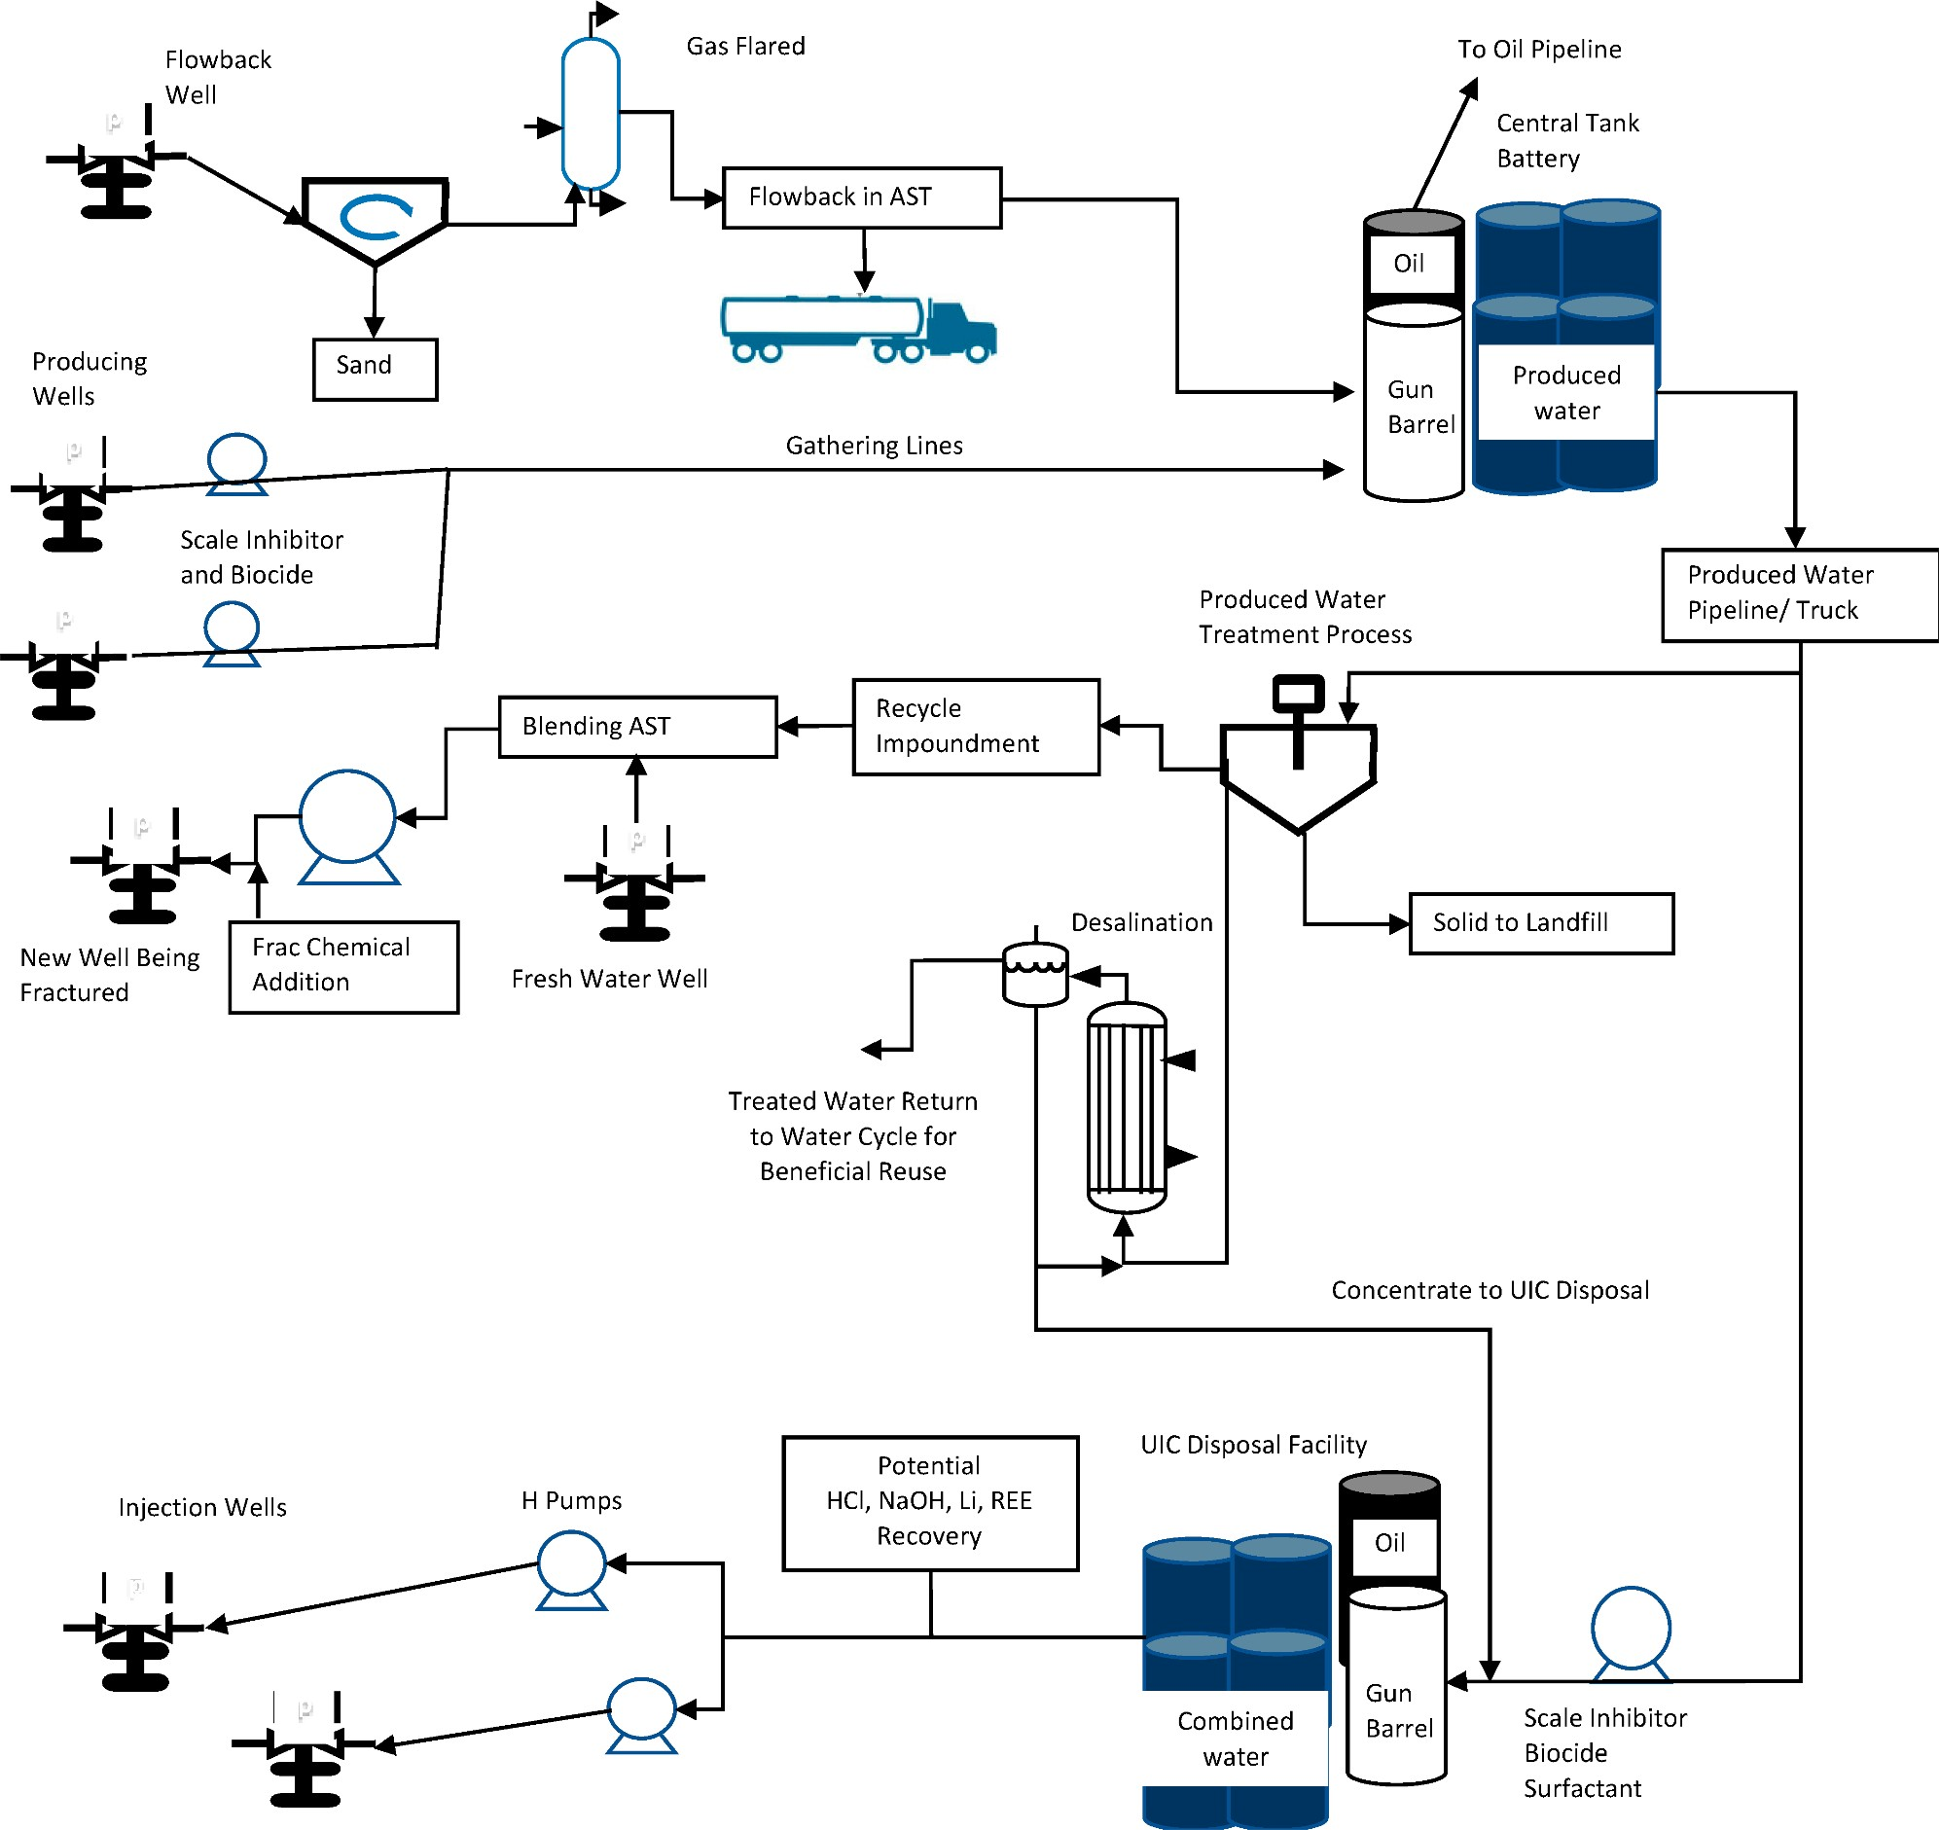

methods are validated, reliable, and appropriate for your specific water samples.

# ### Step 7: Data Analysis and Interpretation

* Record all data accurately, including sample location, date, time, and analytical results.
* Perform any necessary calculations or conversions (e.g., converting raw instrument readings to actual concentrations).
* Compare results to relevant standards or guidelines (e.g., EPA standards, local regulations) to assess compliance.

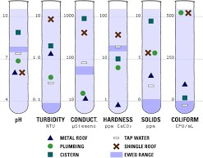

# ### Step 8: Reporting and Documentation

* Prepare a comprehensive report summarizing the methods used, results obtained, and their interpretation.
* Include any observations, anomalies, or issues encountered during the analysis.
* Clearly communicate the conclusions and any recommendations for further action.

# ### Step 9: Follow-Up Actions

* Based on the results, decide if any corrective or preventative actions are required (e.g., water treatment, pollution control measures, additional monitoring).

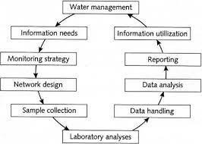

* Implement any necessary changes and continue monitoring as needed.

# ### Step 10;Review and Continuous Improvement:

* Evaluate the effectiveness of the analysis process and results.
* Consider feedback from stakeholders and incorporate any lessons learned for future water analyses.

Remember that water analysis is a critical component of ensuring water safety and quality, so attention to detail and adherence to best practices are essential throughout the entire process.

